**Name: Session:**

**Programming II**

**Lab Exercise 4.16.2020**

In this exercise you are to design a university dorm and meal plan calculator.

Your application is to have 3 forms: a main form, a dorm selection form, and a meal plan selection form. Your main form should allow the user to enter their name, date of birth, college of studies, and major. The program will generate their student ID. The student ID is the sum of the ASCII values of their first name * the sum of the ASCII values of their last name * (numeric month + numeric day + numeric year). The generation should occur when the Generate ID button is clicked.

studentID = sum1 * sum2 * (m + d + y)

sum1 is the sum of the ASCII values of the first name

sum2 is the sum of the ASCII values of the last name

When you select a College, the major list should be populated with the appropriate majors as per the following table.

|  |  |
| --- | --- |
| **College** | **Majors** |
| College of Engineering and Physical Sciences | Electrical Engineering  Mechanical Engineering  Nuclear Engineering  Computer Science  Chemistry  Physics  Astronomy |
| College of Liberal Arts | Art  Communications  English  French  Geography  History  Theater |
| College of Life Sciences and Agriculture | Animal Science  Biology  Environmental Sciences  Forestry  Genetics  Nutrition  Zoology |
| College of Business and Economics | Business Administration  Economics  Hospitality Management |

Your main form will have a *Choose Dormitory* button which will open the Dorm Selection form allowing the student to pick a dorm and return the semester cost to the main form. The Dorm Selection form should return the cost of the dorm choice to the main form.

Your main form will have a *Choose Meal Plan* button which will open the Meal Plan Selection form allowing the student to chose a plan and return the semester cost to the main form. The Meal Plan Selection form should return the cost of the meal plan choice to the main form.

Your main form will also have a *Print*, *Reset* and *Close* button. The *Print* button will print the main form. The *Reset* button will reset all fields. The *Close* button will end the program.

Your main form should also display the total cost of dorm and meal charges for the semester. Use the following table to determine costs.

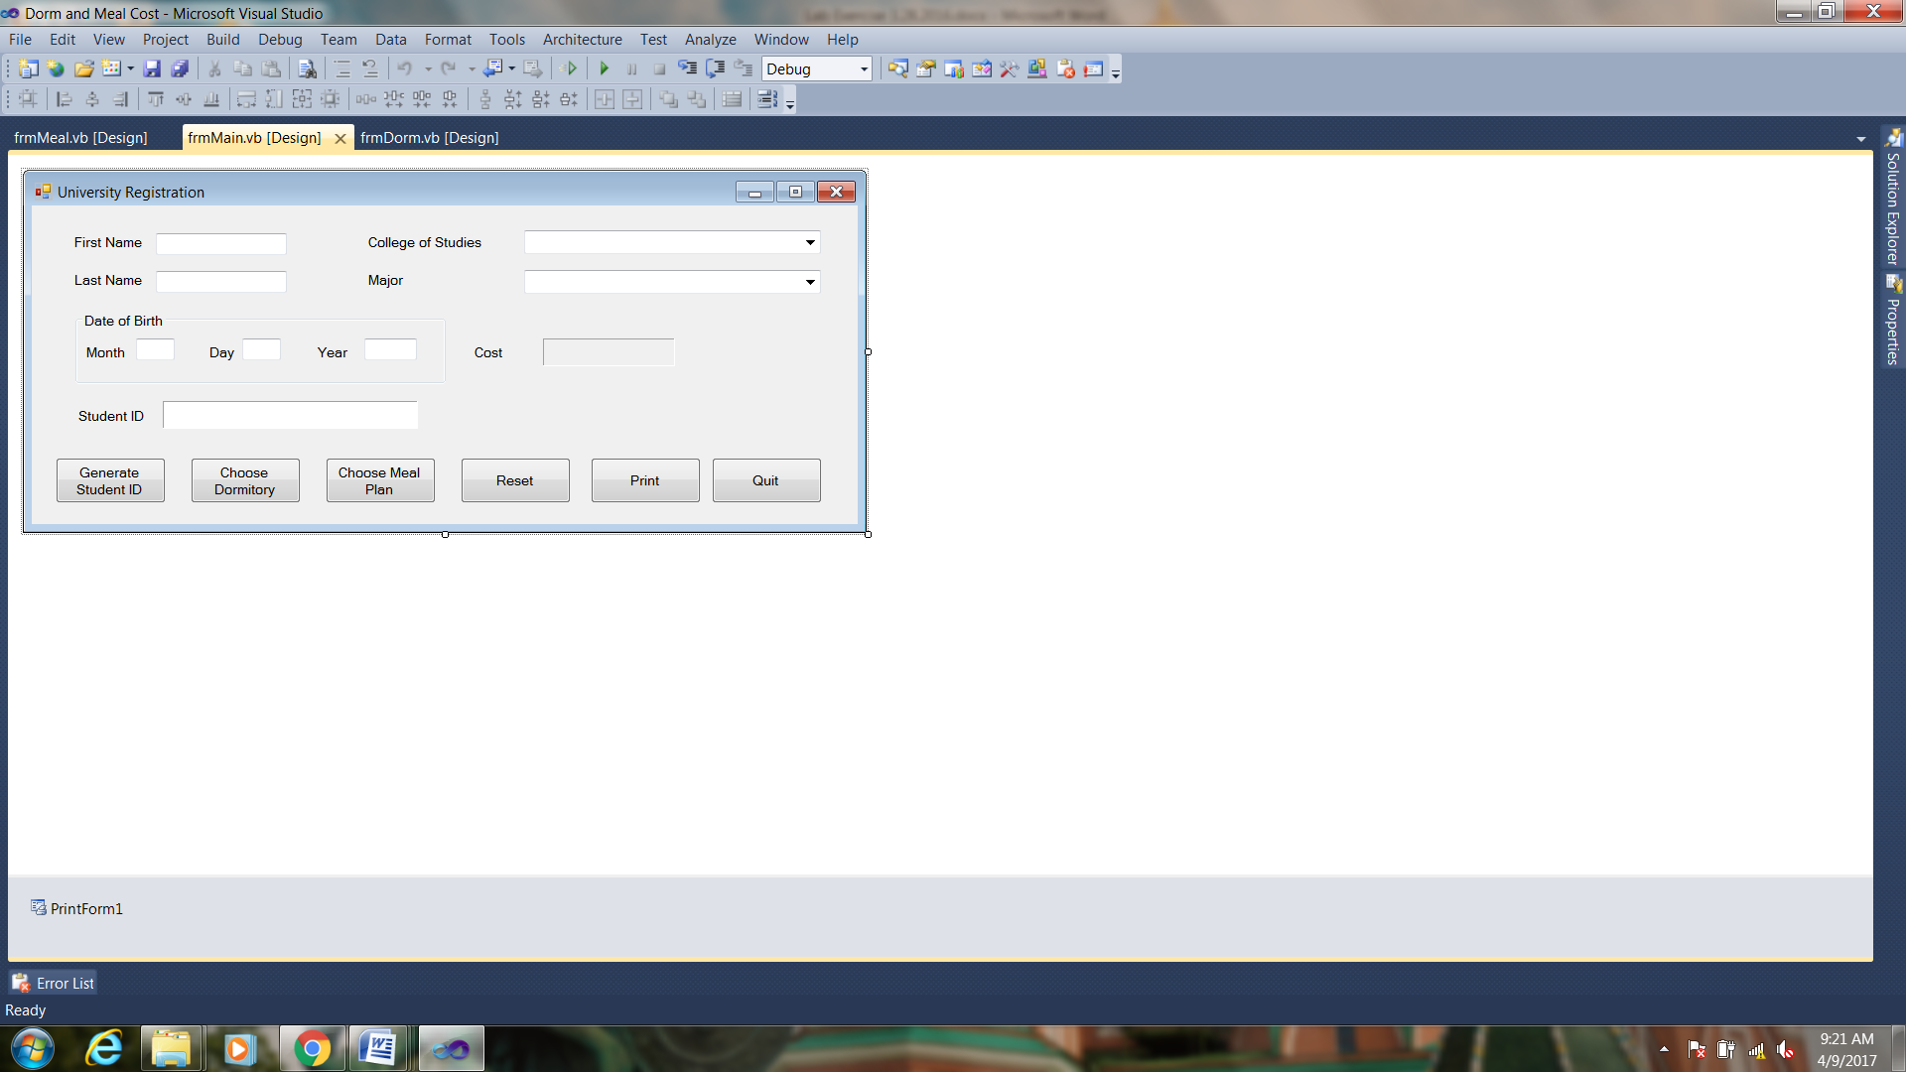

|  |  |
| --- | --- |
| **Dormitory** | **Cost per Semester** |
| Allen Hall | $1500 |
| Pike Hall | $1600 |
| Farthing Hall | $1200 |
| University Suites | $1800 |

|  |  |
| --- | --- |
| **Plan** | **Cost per Semester** |
| 7 meals per week | $560 |
| 14 meals per week | $1095 |
| Unlimited | $1500 |

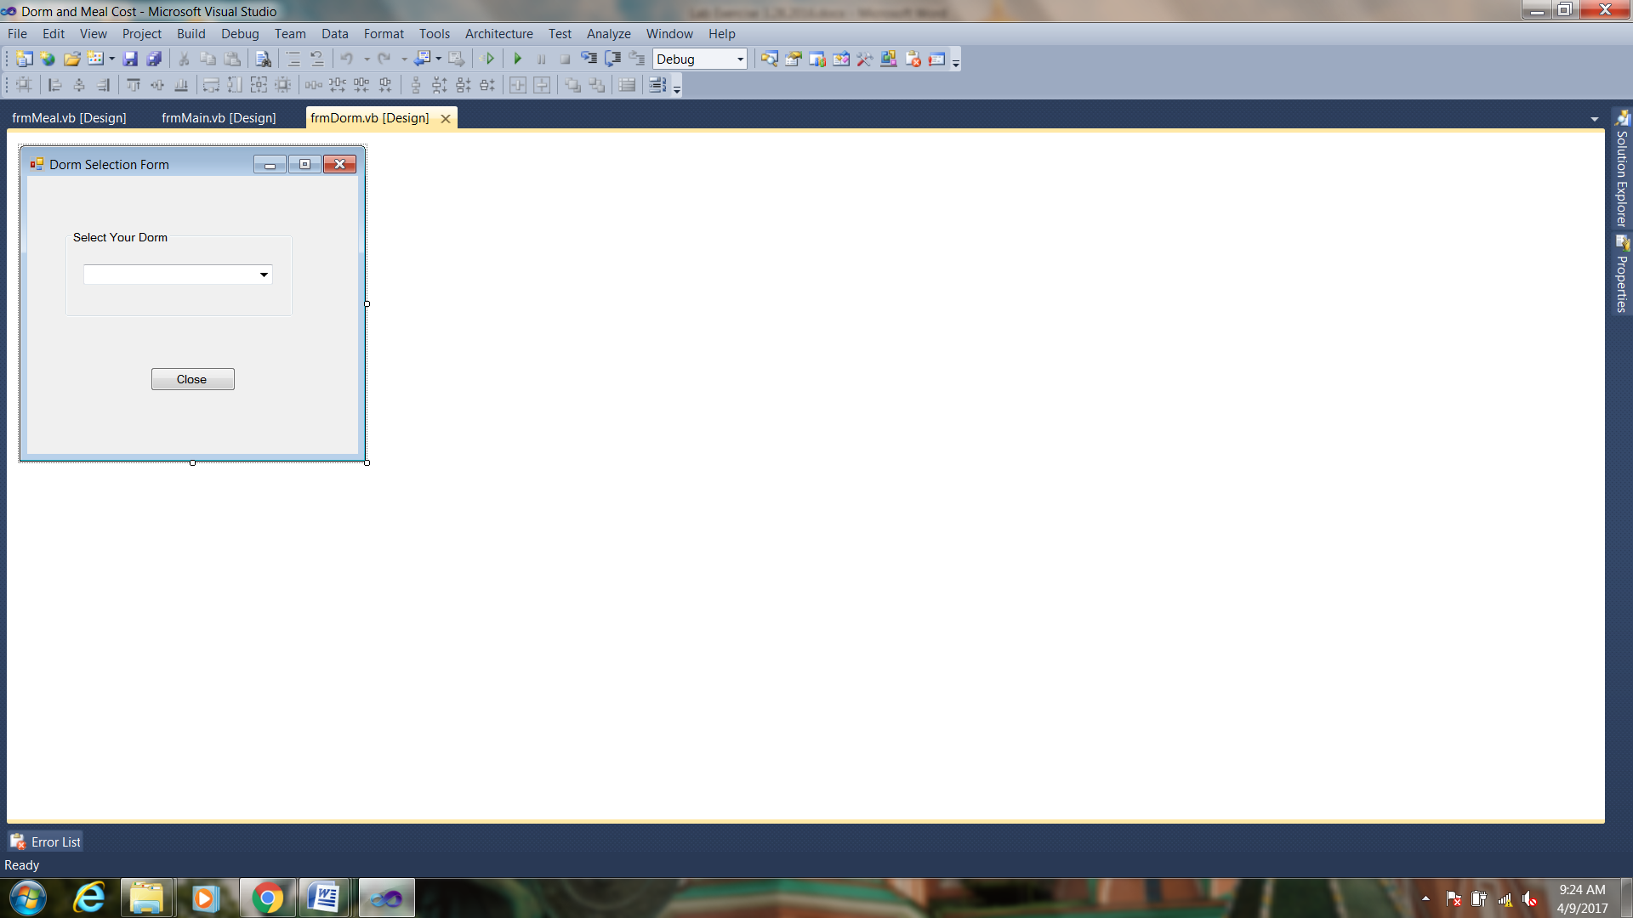 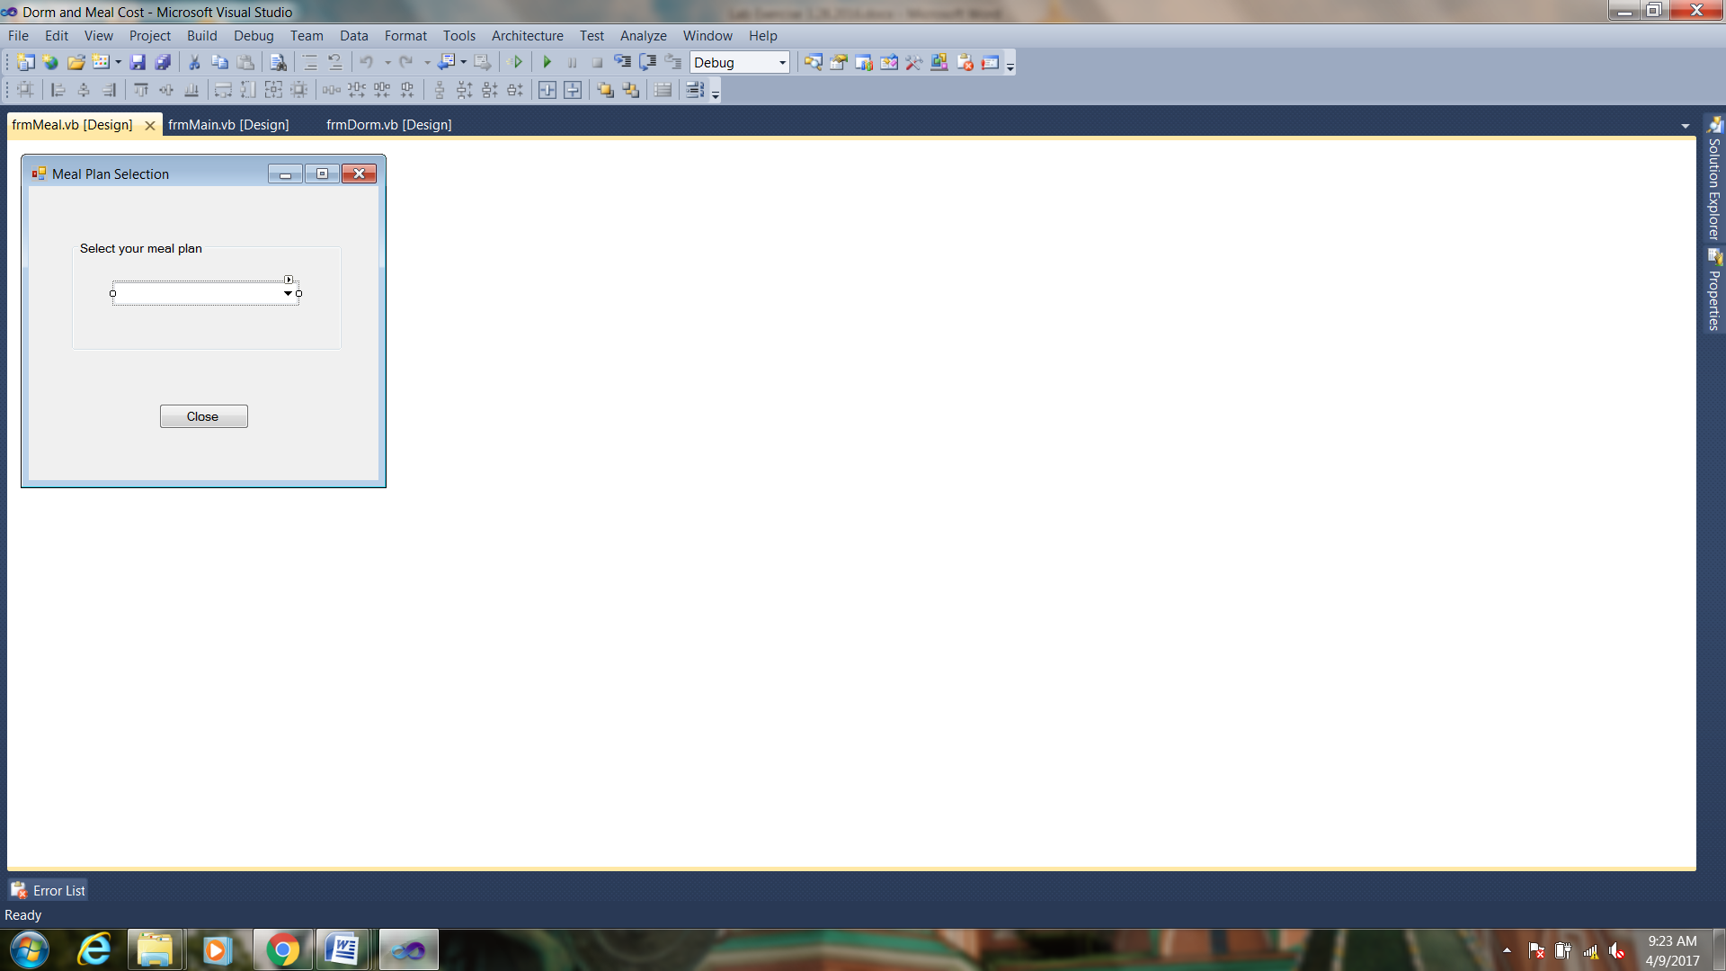

1. Start working on frmMain code.
2. Add the following global variables to the frmMain code.

public static int dormCost;

public static int mealCost;

public static string myDorm;

public static string myMeal;

int total;

1. Add the following code to the btnReset_Click event handler.

total = 0;

mealCost = 0;

dormCost = 0;

txtDay.Text = "";

txtYear.Text = "";

txtFirst.Text = "";

txtLast.Text = "";

txtMonth.Text = "";

lblCollege.Text = "";

lblCollege.Visible = false;

cboCollege.Visible = true;

lblMajor.Text = "";

lblMajor.Visible = false;

cboMajor.Visible = true;

btnDorm.Enabled = true;

btnMeal.Enabled = true;

btnGen.Enabled = true;

lblCost.Text = "";

cboCollege.Text = "";

cboMajor.Text = "";

lblID.Text = "";

lblDorm.Text = "";

lblMealplan.Text = "";

txtFirst.Focus();

1. Add the following code to the btnPrint_Click event handler.

printForm1.Print();

1. Add the following code to the btnGen_Click event handler.

string first, last, studentID;

int m, d, y, sum1, sum2;

Int64 number; //Need 64 bit integer

first = txtFirst.Text;

last = txtLast.Text;

m = Convert.ToInt32(txtMonth.Text);

d = Convert.ToInt32(txtDay.Text);

y = Convert.ToInt32(txtYear.Text);

sum1 = 0;

sum2 = 0;

for (int i = 0; i < first.Length; i++)

sum1 += (byte)first[i];

for (int i = 0; i < last.Length; i++)

sum2 += (byte)last[i];

number = sum1 * sum2 * (m + d + y);

studentID = number.ToString();

lblID.Text = studentID;

btnGen.Enabled = false;

1. Add the following code to the btnDorm_Click event handler.

frmDorm dorm = new frmDorm();

dorm.ShowDialog();

total += dormCost;

lblDorm.Text = "Dorm Assignment: " + myDorm;

lblCost.Text = total.ToString("c");

btnDorm.Enabled = false;

1. Add the following code to the btnMeal_Click event handler.

frmMeal meal = new frmMeal();

meal.ShowDialog();

total += mealCost;

lblMealplan.Text = "Meal plan: " + myMeal;

lblCost.Text = total.ToString("c");

btnMeal.Enabled = false;

1. Add the following code to the cboCollege_SelectedIndexChanged event handler.

switch (cboCollege.SelectedIndex)

{

case 0:

cboMajor.Items.Clear();

cboMajor.Items.Add("Electrical Engineering");

cboMajor.Items.Add("Mechanical Engineering");

cboMajor.Items.Add("Nuclear Engineering");

cboMajor.Items.Add("Computer Science");

cboMajor.Items.Add("Chemistry");

cboMajor.Items.Add("Physics");

cboMajor.Items.Add("Astronomy");

lblCollege.Text = cboCollege.SelectedItem.ToString();

cboCollege.Visible = false;

lblCollege.Visible = true;

break;

case 1:

cboMajor.Items.Clear();

cboMajor.Items.Add("Art");

cboMajor.Items.Add("Communications");

cboMajor.Items.Add("English");

cboMajor.Items.Add("French");

cboMajor.Items.Add("Geography");

cboMajor.Items.Add("History");

cboMajor.Items.Add("Theater");

lblCollege.Text = cboCollege.SelectedItem.ToString();

cboCollege.Visible = false;

lblCollege.Visible = true;

break;

case 2:

cboMajor.Items.Clear();

cboMajor.Items.Add("Animal Science");

cboMajor.Items.Add("Biology");

cboMajor.Items.Add("Environmental Sciences");

cboMajor.Items.Add("Forestry");

cboMajor.Items.Add("Genetics");

cboMajor.Items.Add("Nutrition");

cboMajor.Items.Add("Zoology");

lblCollege.Text = cboCollege.SelectedItem.ToString();

cboCollege.Visible = false;

lblCollege.Visible = true;

break;

case 3:

cboMajor.Items.Clear();

cboMajor.Items.Add("Business Administration");

cboMajor.Items.Add("Economics");

cboMajor.Items.Add("Hospitality Management");

lblCollege.Text = cboCollege.SelectedItem.ToString();

cboCollege.Visible = false;

lblCollege.Visible = true;

break;

}

1. Add the following code to the cboMajor_SelectedIndexChanged event handler.

lblMajor.Text = cboMajor.SelectedItem.ToString();

cboMajor.Visible = false;

lblMajor.Visible = true;

1. Now we will work on the code for frmMeal.
2. Add the following code to the btnClose_Click event handler.

switch (cboMeals.SelectedIndex)

{

case 0:

frmMain.mealCost = 560;

frmMain.myMeal = cboMeals.SelectedItem.ToString();

break;

case 1:

frmMain.mealCost = 1095;

frmMain.myMeal = cboMeals.SelectedItem.ToString();

break;

case 2:

frmMain.mealCost = 1500;

frmMain.myMeal = cboMeals.SelectedItem.ToString();

break;

}

this.Close();

1. Now we will work on the code for frmDorm.
2. Add the following code to the btnClose_Click event handler.

switch (cboDorm.SelectedIndex)

{

case 0:

frmMain.dormCost = 1500;

frmMain.myDorm = cboDorm.SelectedItem.ToString();

break;

case 1:

frmMain.dormCost = 1600;

frmMain.myDorm = cboDorm.SelectedItem.ToString();

break;

case 2:

frmMain.dormCost = 1200;

frmMain.myDorm = cboDorm.SelectedItem.ToString();

break;

case 3:

frmMain.dormCost = 1800;

frmMain.myDorm = cboDorm.SelectedItem.ToString();

break;

}

this.Close();

1. Now run and test your program.

**When you have completed your application, print the forms of your running application and turn in.**